Ordinary Level Questions 2018

1.
The points P and Q lie on a straight level road.
A car passes P with a speed of 5 m s⁻¹ and accelerates uniformly for 7 seconds to a speed of 26 m s⁻¹.
It then travels a distance of 234 metres at a constant speed of 26 m s⁻¹.
Finally, the car decelerates uniformly to rest at Q.
The car travels 52 metres while decelerating.

Find
- the acceleration
- |PQ|, the distance from P to Q
- the average speed of the car as it travels from P to Q.

A motor-cyclist takes k seconds to travel from P to Q.
The motor-cyclist starts from rest at P and accelerates uniformly to a maximum speed of 30 m s⁻¹.
She then decelerates uniformly to rest at Q.

- Draw a speed-time graph of the motion of the motor-cyclist as she travels from P to Q.
- Find the value of k.

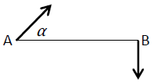
2.
Ship A is moving at a constant speed of 40 km h⁻¹ in the direction α° North of East, as shown where tan $α$ = $\frac{4}{3}$.

Ship B is moving at a constant speed of 38 km h⁻¹ in the direction due South.
Find
- the velocity of ship A in terms of i and j
- the velocity of ship B in terms of i and j
- the velocity of A relative to B in terms of i and j.

Ship B is positioned d km due east of ship A at 2 pm.
The closest distance between ship A and ship B in the subsequent motion is 35 km.
- Show that d = 37 km.

3.
A particle is projected from point P to point S, as shown in the diagram, with initial speed
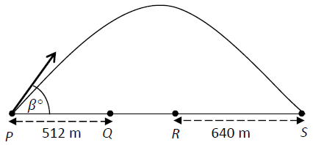
136 m s⁻¹ at an angle of β°to the horizontal where tan $α$ = $\frac{15}{8}$.
The particle passes vertically over the points Q and R during its motion.
Find
- the initial velocity of the particle in terms of i and j
- the time taken to reach the maximum height
- the range of the particle
- the height of the particle when it is vertically above point Q, given that |PQ| = 512 metres
- the speed of the particle as it passes over point R, given that |RS| = 640 metres.

4.
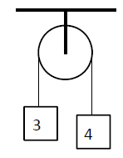
(a)
A particle of mass 3 kg is connected to another particle of mass 4 kg by a taut light inelastic string which passes over a smooth light pulley, as shown in the diagram.
The system is released from rest.
- Find the common acceleration of the particles.
- Find the tension in the string.

(b)
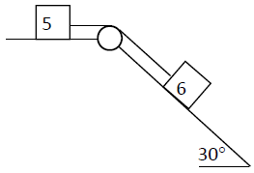
Masses of 5 kg and 6 kg are connected by a taut light inelastic string which passes over a light smooth pulley, as shown in the diagram.
The 6 kg mass lies on a smooth plane inclined at 30° to the horizontal.
The 5 kg mass lies on a rough horizontal surface where µ = $\frac{1}{5}$.
The system is released from rest.
- Show on separate diagrams the forces acting on each particle.
- Find the common acceleration of the masses, in terms of g.
- Find the tension in the string, in terms of g.

5.
(a)
A smooth sphere A, of mass 3 kg, collides with another smooth sphere B, of mass 1 kg, on a smooth horizontal table.
Spheres A and B are moving towards each other with speeds of 4 m s⁻¹ and 2 m s⁻¹, respectively.
The coefficient of restitution for the collision is $\frac{4}{5}$.
Find
(i) the speeds of A and B immediately after the collision
(ii) the loss of kinetic energy due to the collision
- the magnitude of the impulse imparted to A due to the collision.

(b)
A ball is fired vertically upward from the ground with speed y m s⁻¹ so as to just reach a height of 5 metres.
- Find the value of y.

The same ball is then fired vertically downward with speed x m s⁻¹ from a height of 2 metres and just reaches a height of 5 metres after rebounding from the ground.
The coefficient of restitution for the impact with the ground is $\frac{10}{11}$.
- Find the value of x.

6.
(a)
Particles of weight 4 N, 8 N, p N and q N are placed at the points (4, 5), (q, −4), (10, 13) and (−6, 5) respectively.
The co-ordinates of the centre of gravity of the system are (2, p).
Find
- the value of p
- the value of q.

(b)
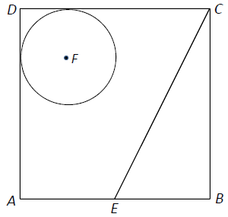
A square lamina with vertices A, B, C and D has both the triangular portion with vertices
E, B and C and the circular portion with centre F and radius 3 units removed.
The co-ordinates of the points are A(0, 0), B(12, 0), C(12, 12), D(0, 12), E(6, 0) and F(3, 9).
Find the co-ordinates of the centre of gravity of the remaining lamina.

7.
A uniform rod, AB, of length 2 m and weight
40√3 N is freely hinged at end A to a vertical wall.
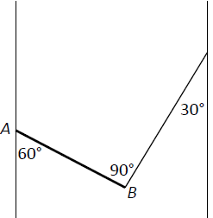
One end of a light inelastic string is attached to B and the other end of the string is attached to another vertical wall, as shown in the diagram.
The rod makes an angle of 60° with one wall and the string makes an angle of 30° with the other wall, as shown in the diagram.
The rod is in equilibrium.
- Show on a diagram all the forces acting on the rod AB.
- Write down the two equations that arise from resolving the forces horizontally and vertically.
- Write down the equation that arises from taking moments about point A.
- Find the tension in the string.
- Find the magnitude of the reaction at the point A.

8.
(a)
A particle describes a horizontal circle of radius 1·5 metres with uniform speed 6 m s⁻¹. The mass of the particle is 1·2 kg.
Find
- the angular velocity of the particle
- the acceleration of the particle
- the centripetal force on the particle
- the time taken by the particle to complete ten revolutions.

(b)
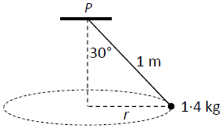
A conical pendulum consists of a particle of mass 1·4 kg attached to a fixed point P by a light inelastic string of length 1 metre.
The string makes an angle of 30° with the vertical.
The particle describes a horizontal circle of radius r metres and the centre of the circle is vertically below point P.
- Find the value of r.
- Show on a diagram all the forces acting on the particle.
- Find the tension in the string.
- Calculate the angular velocity of the particle.

9.
(a)
A solid piece of metal has a weight of 15 N.
When it is completely immersed in water, the metal appears to weigh 11 N.
(i) State the principle of Archimedes.
(ii) Find the volume of the metal.
(iii) Find the density of the metal.
[Density of water = 1000 kg m⁻³]
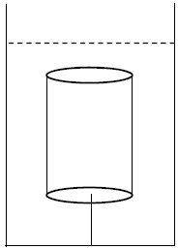
(b)
A solid cylinder has a base of radius 3 cm and a vertical height of 12 cm.
The relative density of the cylinder is 0·6 and it is completely immersed in a liquid of relative density 1·3.
The cylinder is held at rest by a light inelastic vertical string which is attached to the base of the tank.
The upper surface of the cylinder is horizontal.
Find the tension in the string.

